3.19: a) 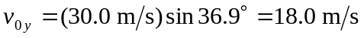; solving Eq. (3.18) for t with 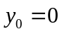 and 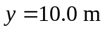 gives
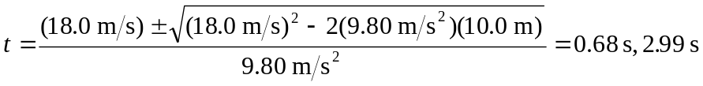
b) The x-component of velocity will be 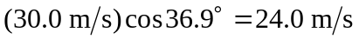 at all times. The y-component, obtained from Eq. (3.17), is 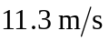 at the earlier time and 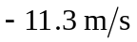 at the later.
c) The magnitude is the same, 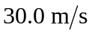, but the direction is now 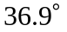 below the horizontal.

